COVER, REVISION HISTORY AND APPROVAL PAGE
Revision No. | Brief Description of Change | Effectivity Date
0 | Origination

 | Name | Signature
Originated/ Revised by: | Jefferd B. Alican  Project Manager | See DCN

Reviewed by: | Engr. Sherman A. Semanero  Operations Manager | See DCN
 | Engr. Virtron K. Bumal-o  Operations Manager | See DCN
 | Marjorie Laranang Olivete  Admin Director/ QMR | See DCN

Approved by: | Fernando C. Laranang  President/CEO | See DCN
Date Approved

Distribution List

President/CEO | Project Manager’s (2) | Document Controller
QMR/BOD’s | Admin (Common Copy)

- PURPOSE AND SCOPE

To develop procedures for forms, rebar, and concrete works to ensure that these works are executed safely and in accordance with the contract requirements and specifications, quality assurance and quality control activities are conducted in a systematic manner, works are inspected, and conformance is verified and documented.

- REFERENCE DOCUMENTS

FCLDC Quality Assurance and Quality Control Manual (FCLDC-QAQC manual)
Plans and Specifications
Procedures manual

- DEFINITIONS

3.1 Definitions

Plans and Specifications - a key part of the process of constructing a project. These documents are means of communicating between parties, and of ensuring that the appropriate designs, materials and construction techniques are used.

Bar Chart/S-Curve – a diagram showing the series of activities against timeliness until completion of the scope of works

FCLDC-Quality Assurance and Quality Control manual – a document that details the description of quality control systems that include staff roles and relationship, procedures and any other resources that relate to producing high quality work output.

Project Engineering and Technical Team - a group of professionals assembled for the execution of a particular project, with each member having a unique skill set vital for the successful completion of the project (PM’s, QS, QCE, Safety Officers, Site engineers etc.)

- GENERAL REQUIREMENTS

4.1 Equipment, Materials and Documents

    - Total Station
    - Leveling tools (laser level, bar level, spirit level)
    - Bar cutter
    - Bar bender
    - Circular saw
    - Scaffolds and accessories
    - Concrete vibrator
    - Computers and office supplies
    - Forms (phenolic boards, pvc boards, etc.)
    - Plans and specifications
    - FCLDC Quality Manual
    - FCLDC QAQC Manual

  - Safety and Environmental

    - Each worksite and employee function are thoroughly assessed in a manner that ensures safety for themselves, property owners and representatives, the general public, and the environment.

- PROCEDURE / INSTRUCTIONS

Procedure Outline

5.1 Safety and Procedures Orientation

5.2 Project Scheduling and material take-off

5.3 Execution and Monitoring

5.4 Work Inspection

Procedure Details

Responsible Person | Activities | Interface Document/Person
 | 5.1 Safety and Procedures Orientation
Quality Control Engineer,  Safety Officer,  HR Representative | - Conduct orientation on safety protocols, site rules and work hazards on the specific work.  - Orient the workers on the importance of quality control and assurance during the execution of works. | Project manpower
 | 5.2 Project Scheduling and Material take-off
Project Technical Team,  Quantity Surveyor | - Provide specific schedule for the workers guide. It is important that they are aware of their schedule to navigate the assigned work in a manner that meets the target timelines.  - It is the function of the site engineer to oversee the projection of materials to be used for the specific work to ensure that the resources have been allocated to the task. Use the material take-off schedule form to list down the needed materials and their corresponding dates of delivery.  - Create the project’s manpower schedule to establish the required manpower for each scope of work. This will be submitted to the Human Resources Department for their reference in manpower hiring. | Bar Chart/S-Curve, Materials Take-off Schedule form, Manpower Schedule
 | 5.3 Execution and Monitoring
Site Engineer,  Foreman  Site Engineer,  Quality Control Engineer,  Foreman  Site Engineer,  Quality Control Engineer,  Foreman  Site Engineer,  Quality Control Engineer,  Foreman  Site Engineer  Site Engineer  Site Engineer  Site Engineer  Site Engineer  Site Engineer  Foreman  Site Engineer  Foreman  Site Engineer  Foreman  QCE  Site Engineer  Foreman  Site Engineer  Foreman  Site Engineer  Foreman  Site Engineer  Foreman  Site Engineer  Foreman  Site Engineer  Foreman  Site Engineer  Foreman  Site Engineer,  Quality Control Engineer,  Foreman  Site Engineer  Foreman  Site Engineer  Foreman  Site Engineer  Foreman  Site Engineer  Foreman  Site Engineer  Foreman  Site Engineer  Foreman  Site Engineer  Foreman  Site Engineer  Foreman  Site Engineer,  Quality Control Manager/  Engineer,  Batching plant supervisor,  Foreman  Site Engineer,  Quality Control Engineer,  Foreman  Site Engineer,  Quality Control Engineer,  Foreman | 5.3.1 Lay-out and Staking  - Site Engineer to issue approved plans and coordinate with the foreman to layout the area to be implemented.  Before releasing of plans to the foreman, the site engineer is responsible in checking if there are discrepancies in the structural plans to that of the architectural plans, mepf plans, and the actual site condition.  All issues in the plans and in the actual lay-out shall be addressed by the technical team in consultation with the owner/owner’s representative or the designer if the need arises.  Use the forms:  Request for Information (FM-OPN-02-05) and/or Request for Approval (FM-OPN-02-05) to formally communicate your concerns.  Attach shop drawings to these forms for better documentation and visualization of the concerns. This is to ensure that any discrepancies and/or any other required provisions will be addressed and included in the implementation.  - The site engineer together with the foreman will determine the dimensions and establishes the lay-out based on the approved plans. The layout will be the common reference for the distances, alignment, plumbness, and elevations.  - Use the total station and other lay-out instruments like string lines, laser levels to ensure precise placement and positioning of the layout markings. This step helps in maintaining the correct placement of the materials to be installed and of the structure.  5.3.2 Form and rebar works for foundations  - Foundation rebars shall rest on lean concrete or gravel bedding depending on the design specifications. The Quality Control Engineer checks the prepared area to see if it conforms to the required depth and foundation dimensions.  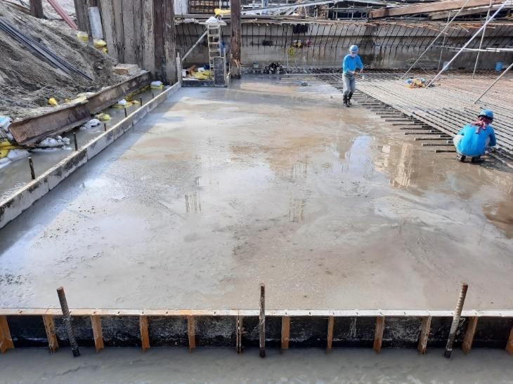  Poured foundation lean concrete ready for lay-out and laying of foundation reinforcements.  - Fabricate the rebars following the given foundation cutting list. Visual inspections shall be necessary to ensure that all bent reinforcements are free from any cracks. Ensure that all bends and hooks are in accordance with section 407.2 and 407.3 of the NSCP 2015 or in the structural plans and specifications provided by the designer  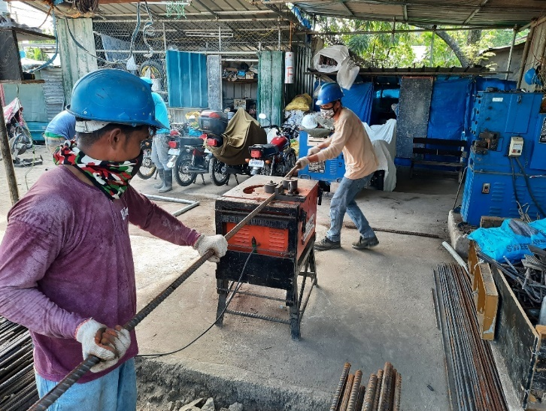  On going fabrication of foundation reinforcements using rebar fabrication equipments (bar cutter and bar bender)  - With the established foundation lay-out, install the foundation bottom bars and tie the intersections using #16 g.i. tie wires. Ensure the correct placement of the transverse and longitudinal layers of the bottom reinforcements. In cases of rebar splicing of foundation rebars, ensure a staggered splicing spaced at least 60cm from each other and following the required lap length prescribed by the structural specification or the NSCP 2015. Provide concrete spacers beneath the transverse layer to maintain the required concrete cover. Concrete spacers shall be of adequate strength and the thickness is in accordance with section 407.8 of the NSCP 2015 or as per the structural specification.  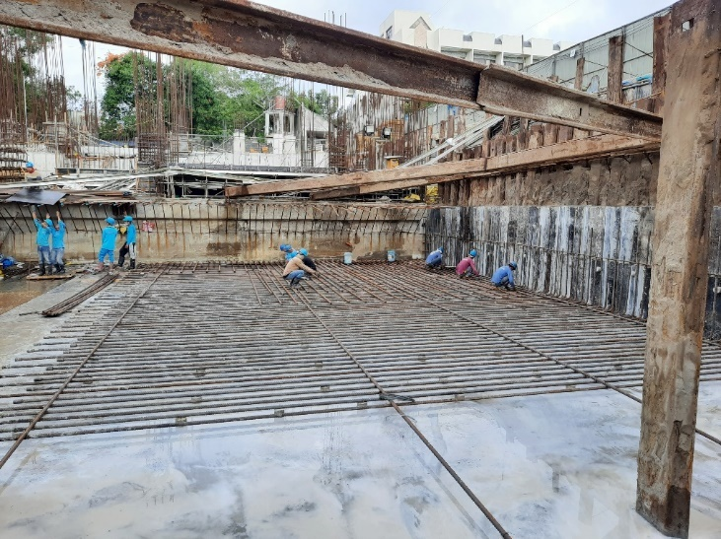  On going installation of foundation bottom reinforcements  - Assemble a temporary scaffold that can efficiently support the vertical installation of rebars. These scaffolds are usually made up of g.i. pipes or h-frames and can be removed upon permanently anchoring the rebars.  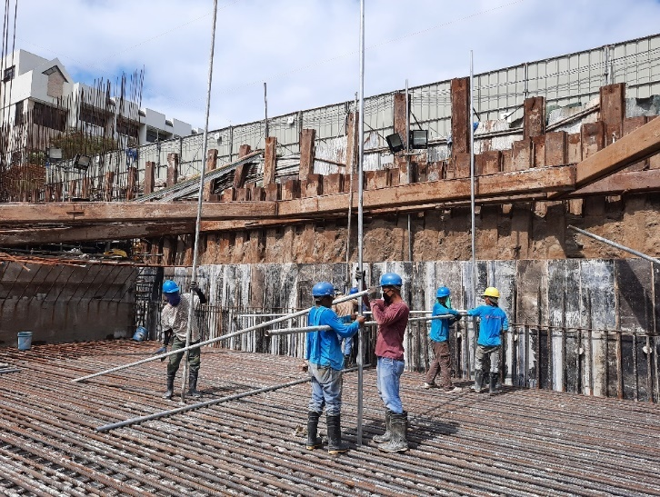  On going assembly of scaffolds for columns and rc wall reinforcement bracing  - Install the column reinforcements and anchor them at the assembled scaffolds to avoid displacements which will affect its alignment. The vertical column reinforcements are erected first noting the sequence of installation to attain the requirements of staggered splicing. Installation of the lateral ties comes after following the set and spacing of ties from the specifications.  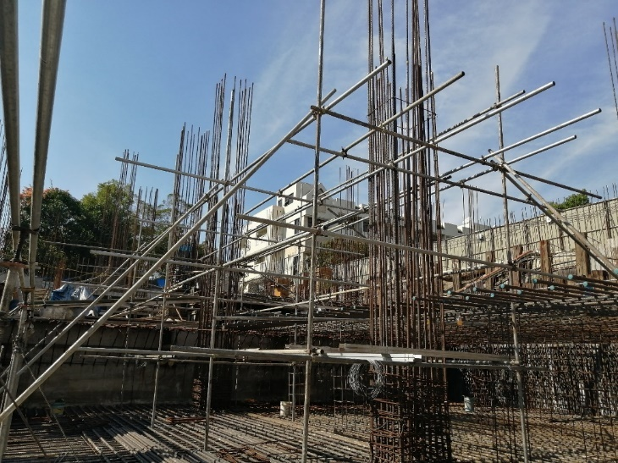  Installed column reinforcements anchored at temporary scaffolds  - Fabricate and install the forms for the concrete termination and construction joints of the foundation. Specifications for the foundation construction joints can be seen on the approved plans. Also check and install if there are provisions of shear bars for the construction joints.  Adequate support should be provided to prevent any displacement of the formwork system. Use sturdy and reliable shoring materials to maintain the system’s structural integrity.  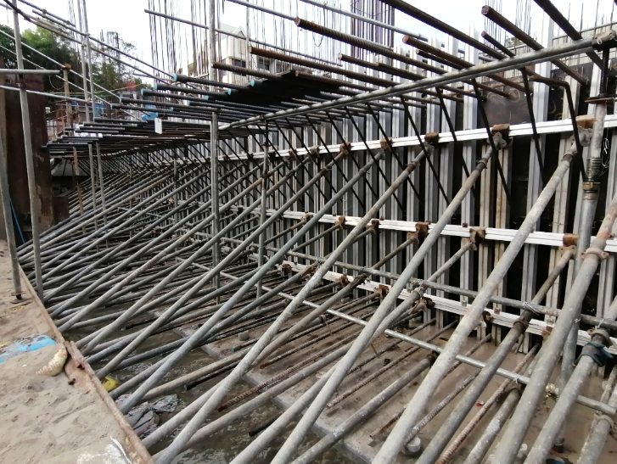  Installed forms for foundation concrete termination  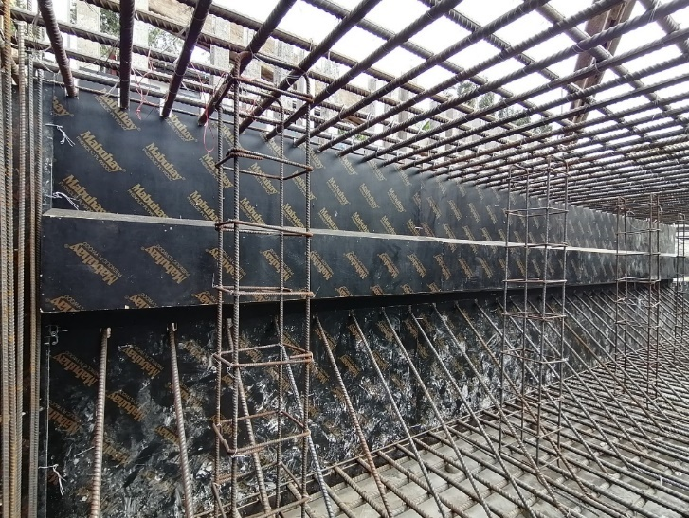  Installed forms for foundation concrete termination and construction joint  - Check the plans if there are grounding systems that need to be placed in the foundation area to be accomplished. Ideally, install the grounding systems before the laying of the foundation top bars.  - Install the chair bars resting and tied on the bottom rebars, this will be the holder of the foundation top bars and used to maintain the distance between the bottom and top reinforcements. Ensure that the installed chair bars are sufficient to carry the weight of the top bar reinforcements and other elements that will rest on top of it.  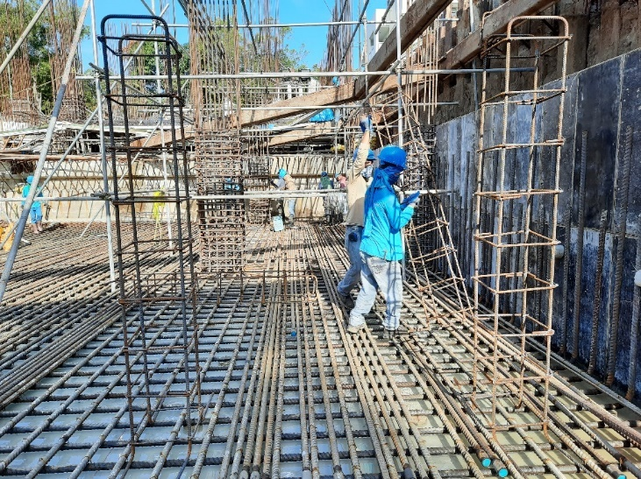  On going installation of foundation chair bars  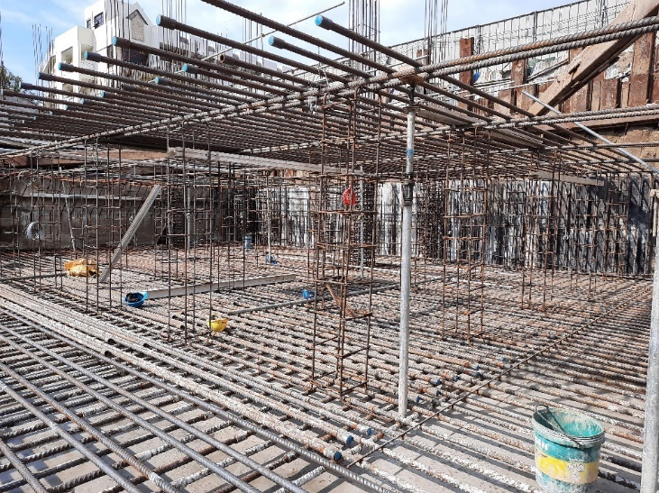  Installed chair bars in between bottom and top bar reinforcements  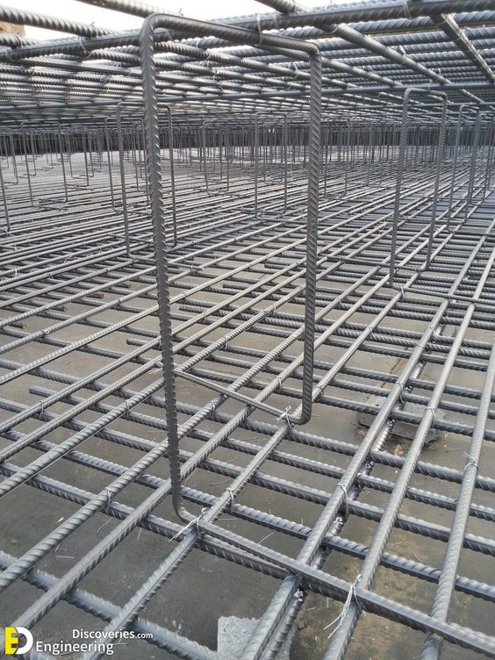  Installed chair bars in between bottom and top bar reinforcements  - Lay and tie the foundation top bars following their marked spacing and alignment.  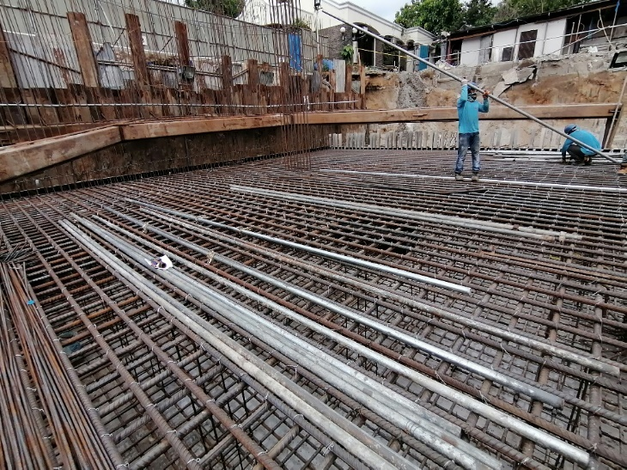  Installed foundation top bars  - Install the reinforcements of other elements like retaining walls, shears walls, and other rebars that needs to be embedded on foundation.  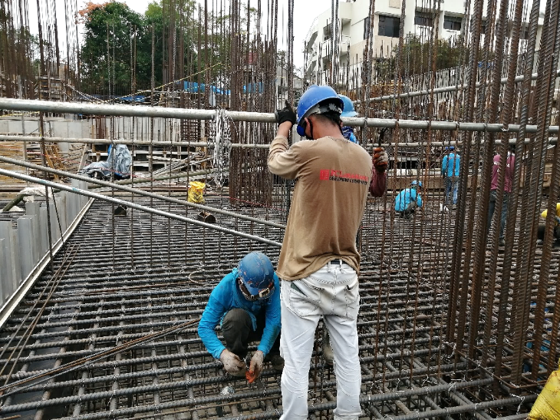  On going installation of rc wall/shear wall rebars embedded on foundation  - Provide a concrete pouring guide to maintain the consistency of thickness for the foundation concrete cover.  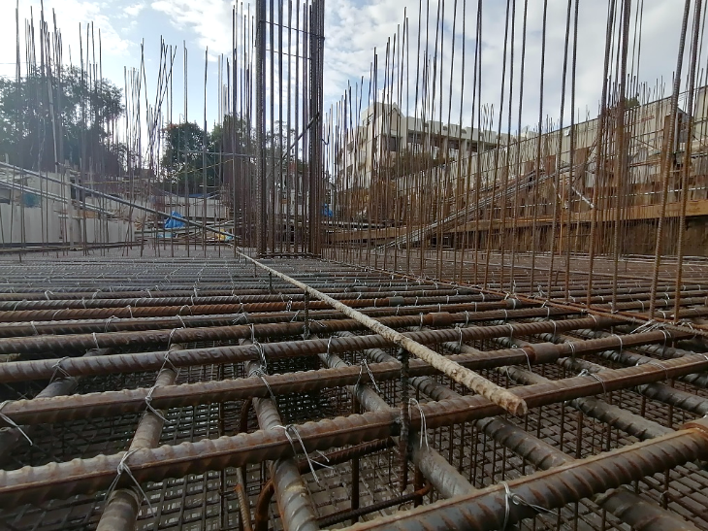  Installed concrete pouring guide  - Throughout the implementation of the rebar and form works, the quality control engineer ensures the correctness of the implementation by inspection of the quantity, placement, alignment, and positioning of all the materials and scaffolds installed. Any discrepancies shall undergo adjustments prior to the concrete pouring of foundation.  - Clean the foundation reinforcements prior to concrete pouring. A clean reinforcement gives a good bonding with the concrete.  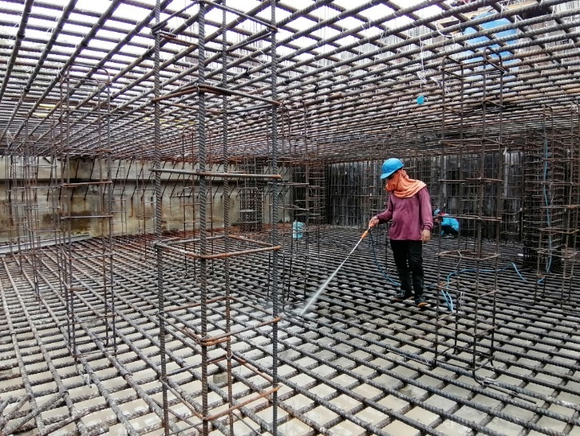  Cleaning of foundation rebars using power sprayer  5.3.3 Form and rebar works for columns, retaining walls, and shearwalls  - Fabricate the needed reinforcements following the cutting lists and the approved plans released by the site engineer.  - Assemble supporting scaffolds for the installation of reinforcements.  - For columns, mark the spacing of lateral ties which will be the guide for its placement. The lateral ties are placed in a way that it shall encircle the main vertical reinforcements and hooked at its end and secured properly with tie wires to prevent slipping or movement. Refer to the column schedule in the plans and specifications to determine the details of the column reinforcements to be installed which includes the bar diameters and the number of sets and spacings of the lateral ties.  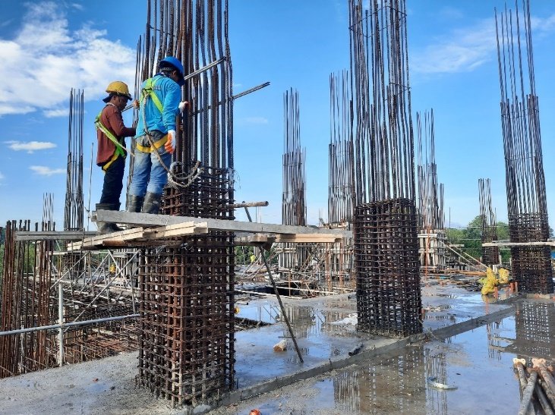  On going installation of column lateral ties  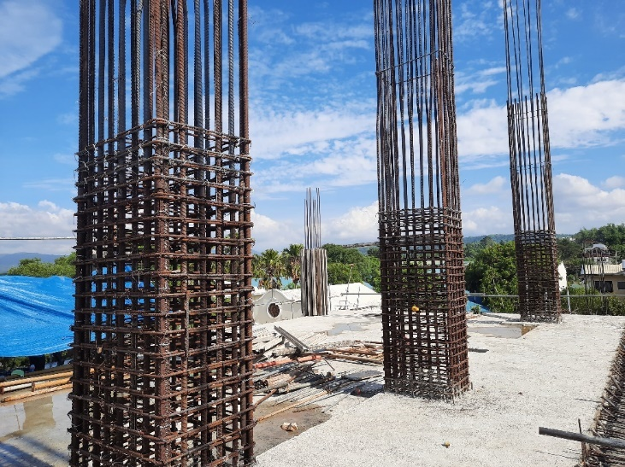  Installed column lateral ties  - Install the vertical reinforcements following the sizes and sequence of installation stipulated in the column schedule and cutting list. Anchor the spliced vertical reinforcements in the installed lateral ties using tie wires of sufficient lengths. Splicing methods can be done using a lapping or coupling method of splicing. No more than 50% of the total number of main bars shall be spliced at any location of the same level. The length and location of the splicing requirements shall be defined by the structural designer in the provided plans and specifications which are usually seen on the structural general notes.  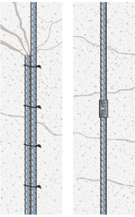  Lapping Coupler  Methods of rebar splicing  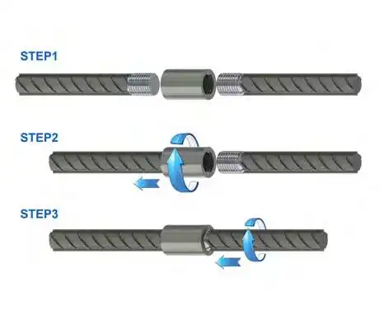  Coupler method of rebar splicing  For coupling method of splicing, rebar couplers or mechanical splices are used to connect reinforcement bars of various grades and diameters. They eliminate the use of lapping and welding. Rebar couplers can join rebars with full tension capacity.  The ends of steel bars to be joined are provided with threads, and a coupler is used to join rebars end-to-end.  Advantages of coupler method of splicing:  1. Rebar Continuity – They do not depend on the concrete for load transfer, the loads are transmitted across the connection.  2. Reduction of rebar congestion - Lapping rebar in heavily reinforced sections can cause significant congestion, resulting in problems fixing the steel and insufficient room for the proper placement and compaction of the concrete. The use of rebar couplers will significantly reduce congestion, making the placement and compaction of the concrete easier, leading to less risk of concrete segregation due to over-vibration and, as a result, an increase in the concrete quality.  3. Reduction in steel use - The use of rebar couplers reduces steel consumption and can therefore be an environmentally friendly and more sustainable option than lapping. The rebar steel saving is equivalent to the lap length.  4. Ease of construction – fast and easy to install  5. Cost effective – reduces labor costs due to the acceleration of work schedules.  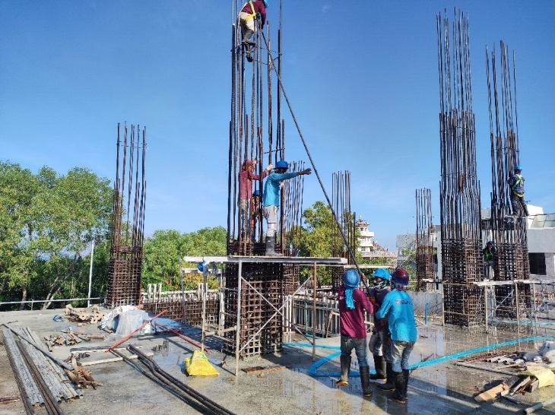  On going installation of column vertical splices  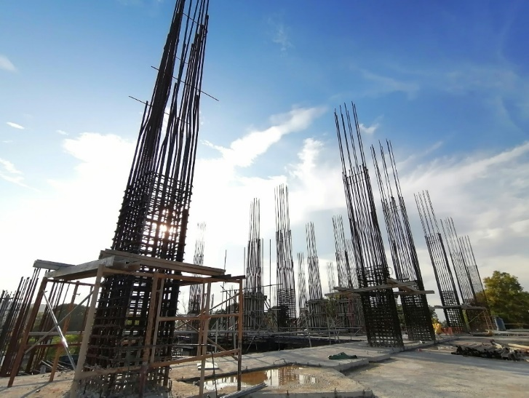  Installed column reinforcements  For retaining walls and shear walls, install the reinforcements in conformance to the given cutting list and to the design specifications. If the wall is designed to have a double reinforcement, the outer reinforcements are installed first before its inner reinforcements.  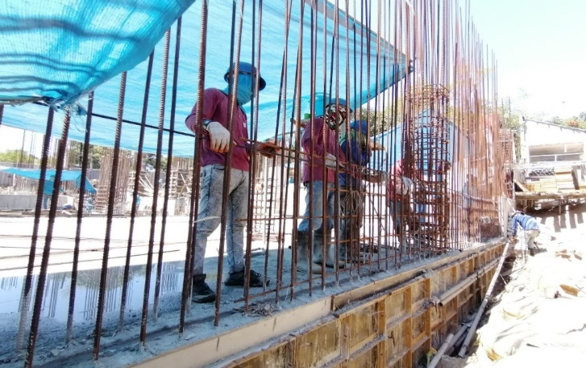  On going installation of rc wall reinforcements  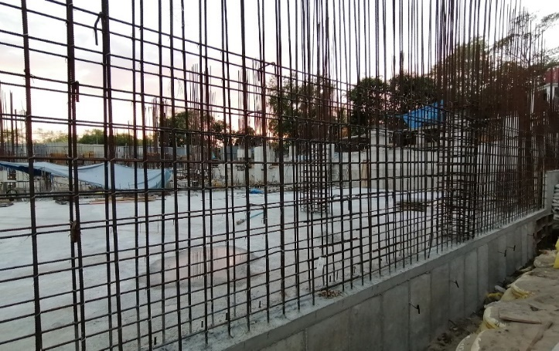  Installed rc wall reinforcements  The sequence of rebar installation will be repeated depending on the floor-to-floor height which dictates the height of the member.  - Fabricate the needed forms according to the required dimensions. It is important to note that the cutting of the forms is planned accordingly for it to be reused multiple times. In typical floors, it is advisable to number the forms for its proper sequence of reinstallation.  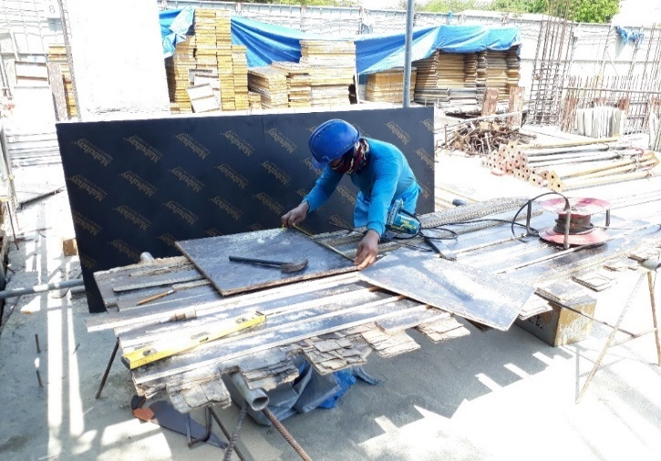  On going fabrication of forms  - Before enclosing the rc wall reinforcements with forms, lay a water stop on the construction joint for water leakage prevention on the joints especially if the rc wall is exposed to earth that can be a factor for water leakage. Add reinforcements to water stop to prevent its displacement during concrete pouring.  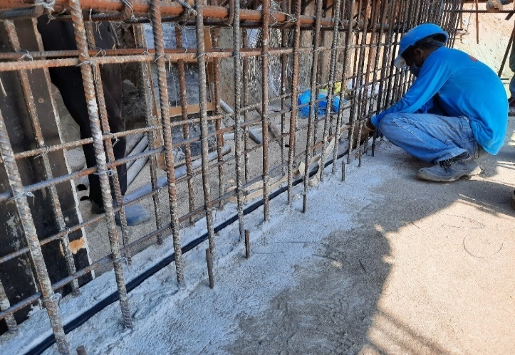  On going installation of water stop on rc wall  - Once the form panels are cut, install spacers of sufficient thickness to attain the specified rebar concrete cover. Carefully place the fabricated form panels in position according to the marked layout. Ensure that the panels are securely attached to each other and to the supporting structure. Use appropriate fasteners such as nails and tie wires or braces such as aluma beams to hold the form panels in place. Simultaneously check the elevation, alignment, and plumbness using hand tools like plum bob, squala, and bar levels.  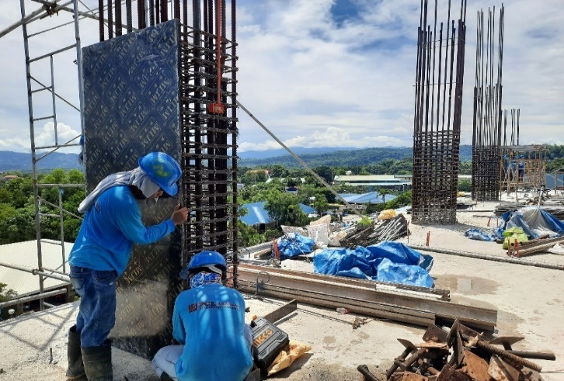  On going installation of column forms  - Install the bracing, which is a temporary support structure used to hold the formwork panels in place until the concrete have been casted. Combinations of aluma beams, g.i. pipes, pipe walers, and tie rods of various lengths are typically used for bracing the forms.  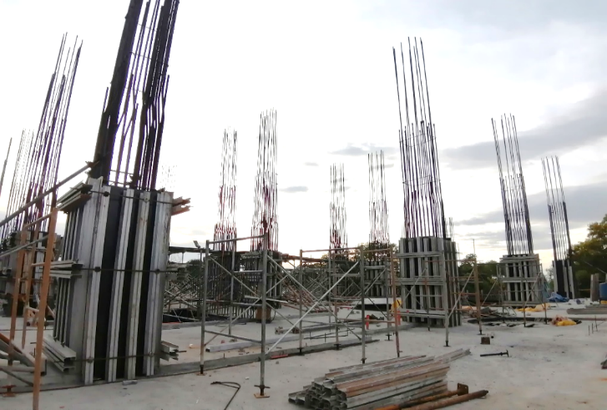  Installed form braces for columns using aluma beams,tie rods, pipe walers  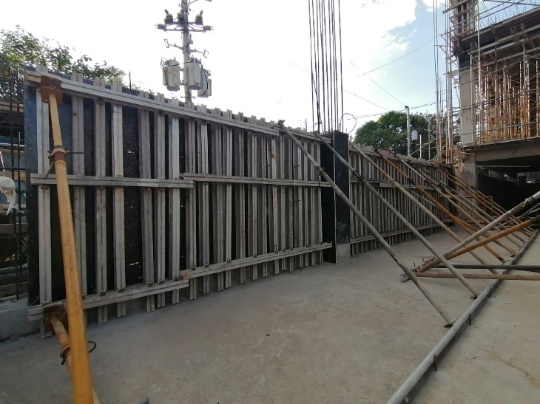  Installed form braces for rc walls using aluma beams,tie rods, pipe walers  - Install shoring jacks to maintain the alignments, plumbness, and enhance the strength and load-bearing capacity of the forms. Proper shoring and bracing are essential for the stability of the formwork system during the concrete pouring process.  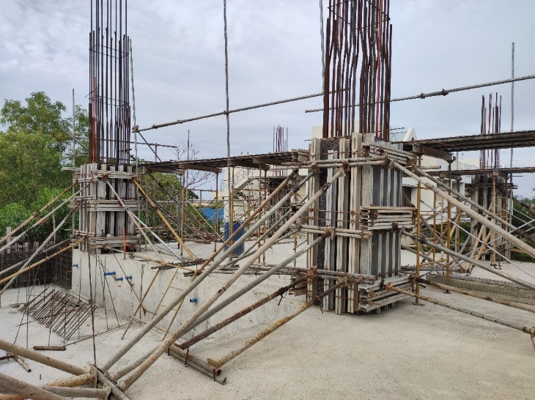  Installed forms, braces, and supports for columns  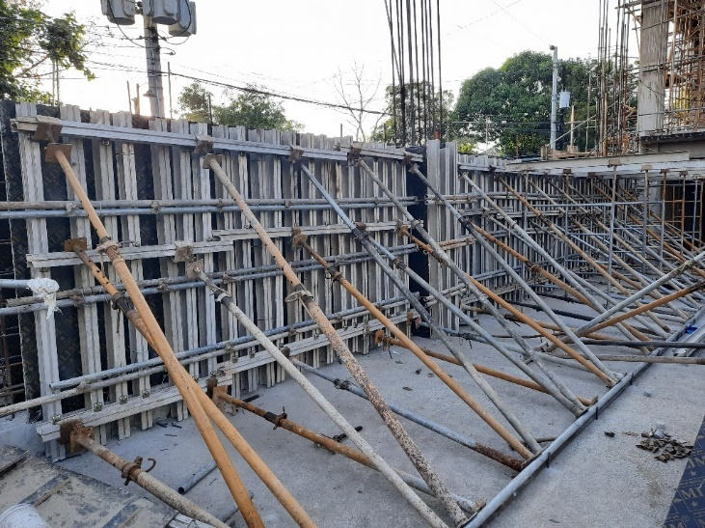  Installed forms, braces, and supports for rc walls  - After the formwork system has undergone quality inspections by the Quality Control Engineer, set up the concrete pouring platforms which are leveled on the top surface of the installed forms. This serves as the working area and mixing board of the pouring crew.  5.3.4 Form and rebar works for beams and slab  - Assemble the scaffolds for beam runner. All scaffolds and accessories should rest on a solid ground; sole boards made of wood planks, sheet piles, or other materials that can efficiently support the formwork system and the placement of concrete are used in cases where the ground is soft.  - The first layer scaffolds are erected first and then followed by the second and third lifts depending on the floor elevation specified in the plans.  Pin connectors, cross braces, or clamps are used to connect the scaffolds together while adjustable base jacks and u-heads are used to adjust the scaffoldings to its desired elevation.  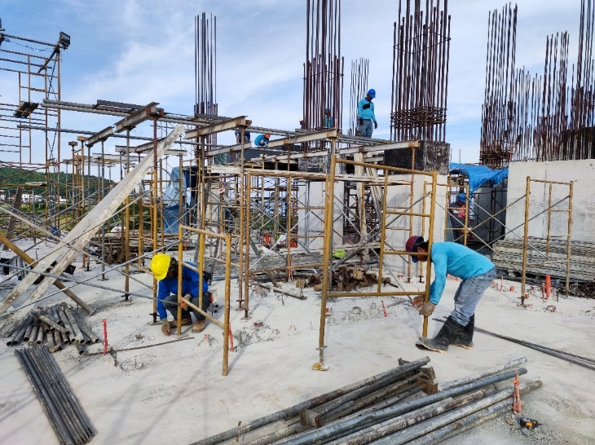  On going erection of beam and slab scaffolds  - Provide a reliable bracing system for the scaffolds to ensure their stability until the concrete is set. Be mindful of the arrangement and alignment of the scaffolds to provide sufficient manpower and material access. For large projects or large area of beams and slabs, it is advisable to provide a shop drawing for the arrangement of scaffolds.  - The primary girders (“sipo”) and secondary girders (“soleras”) mostly composed of aluma beams or g.i. pipes are set and fixed using aluma clips or g.i. tie wires.  - Fabricated runner and phenolic boards of at least ½ inch thickness are placed and fixed on top of the secondary girders. This will serve as the platform which the beam reinforcements will rest.    On going installation of beam runners  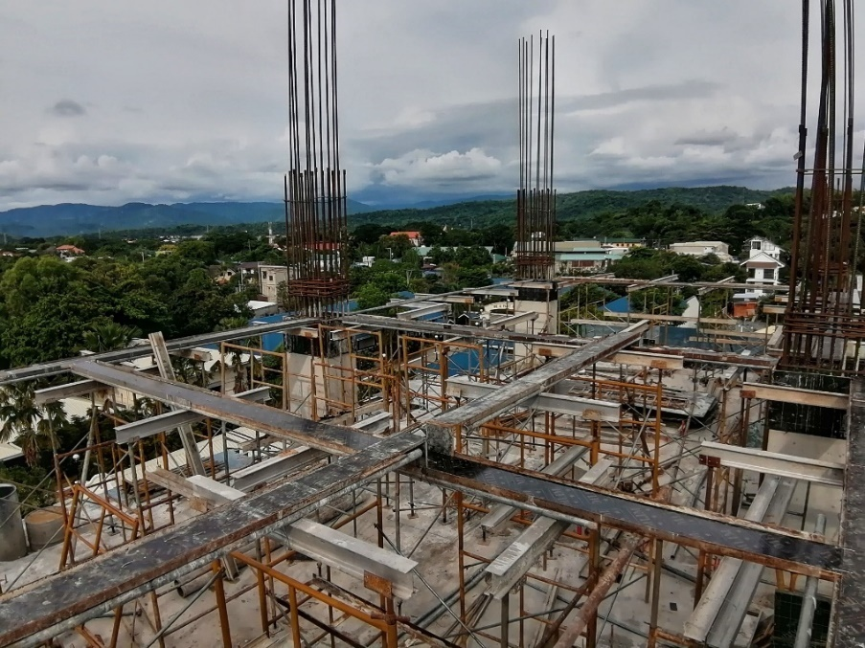      Installed beam runners  - Install a temporary top bar holder at a slightly higher level than the beam elevation. Install the required top bars which will temporarily rest on the top bar holder. Follow specified splicing lengths and zones specified in the cutting list and structural specification. Also, refer to section 407.1-407.9 of the NSCP 2015 or the FCLDC QAQC manual for the standards or rebar splicing, development length, lapping, bending, and anchorage.    On going installation of beam reinforcements  - Based on the beam schedules, mark the spacing of the stirrups using a chalk stone. Install the required stirrups by inserting the top bars through it, with the hooks on the top portion and laid in an alternate manner (left, right, left and so on..)  - Insert the main bottom bars at desired location and splice zones and tie the beam stirrups to it following the required spacing.  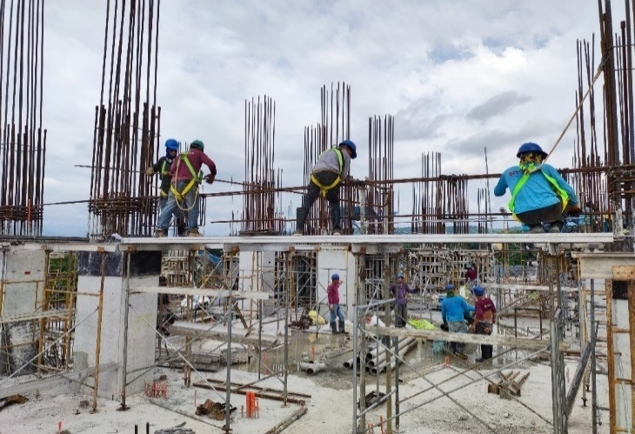  On going installation of beam main reinforcements and stirrups  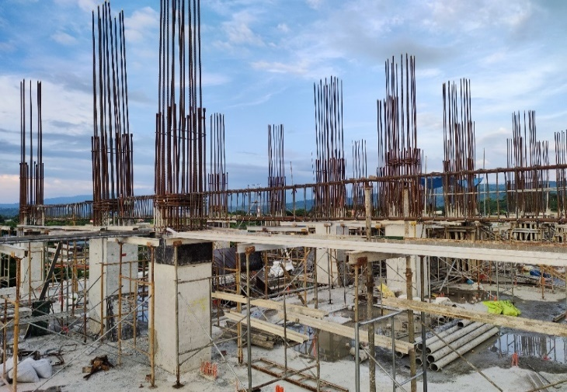  Installed beam main reinforcements and stirrups  - Lower the main beam rebars at the desired elevation and insert the beam cut/extra bars and web bars. Use a separator/spacer bar of 25mm minimum diameter should there be two or more layers of top bars and bottom bars.  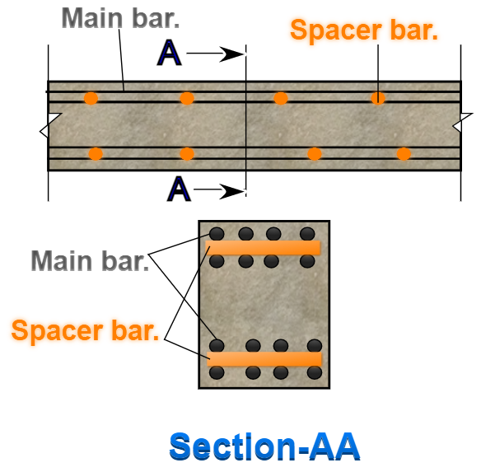  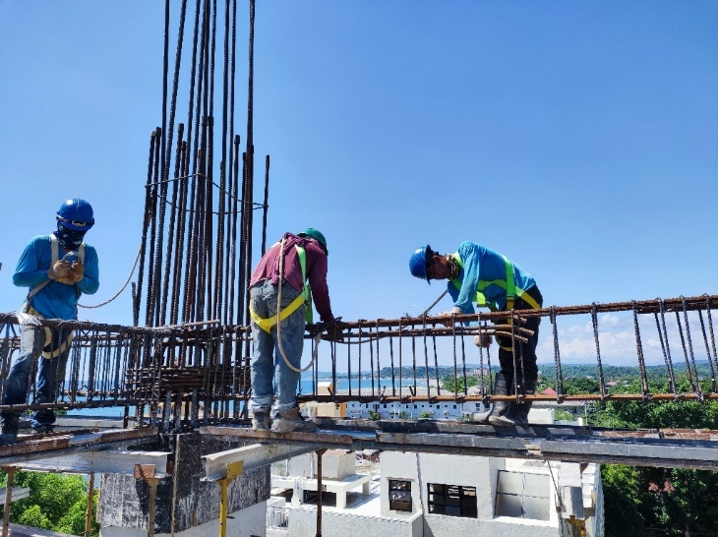  On going installation of beam cut bars  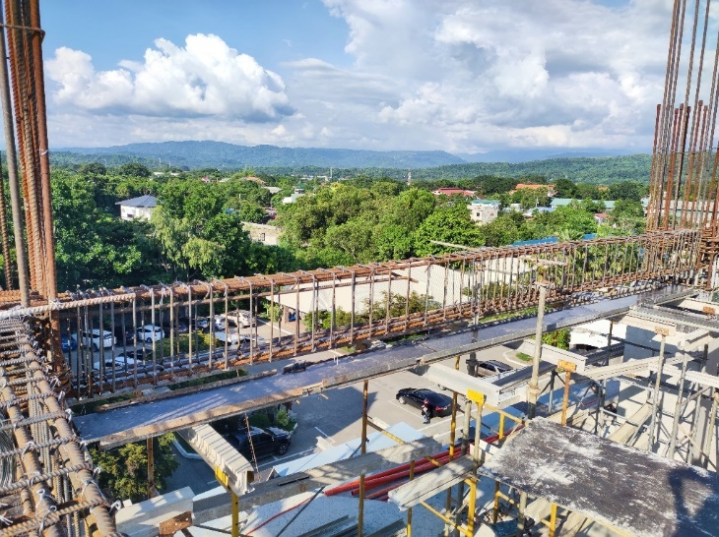  Installed beam reinforcements  - Install 40mm thick concrete spacer blocks for protective covering by tying it on both sides of the stirrups and at the bottom bars. For structural elements that are exposed to earth, use 50mm thick concrete spacers. Refer to the design specifications for the design strength of concrete spacers.  - After the beam rebars have been placed. The beam siding forms can be installed. Provide additional bracings using aluma beams and/or gi pipes for the stiffness of the beam forms. The site engineer together with the quality control engineer are responsible in ensuring that the installed support for the slab and beams are sufficient.  In the presence of beam cambering, refer to the design and specifications for details.  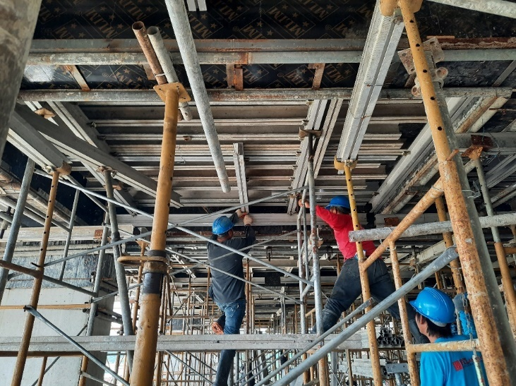  On going installation of additional bracings for beam forms  - Set up the slab scaffolds in the same manner as the setting up the scaffolds for beams. Phenolic boards or pvc boards of ½ inch thickness are placed on top of the secondary girder and secured using nails and tie wires.  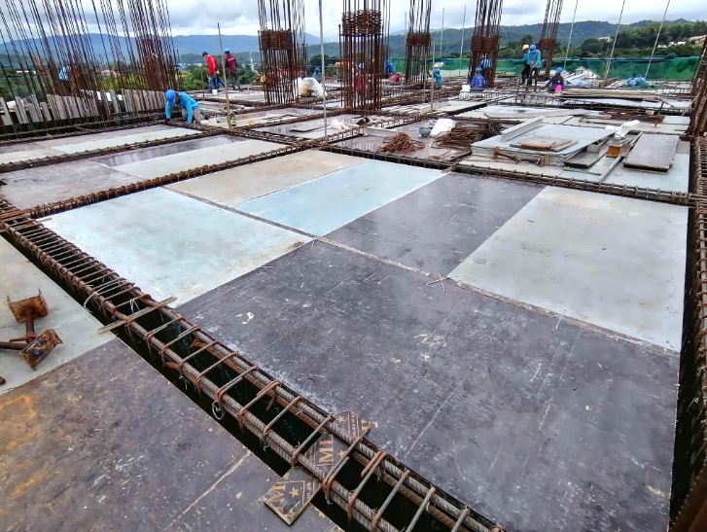  Installed slab forms  - Clear the area of any obstruction for the slab rebar installation.  - Lay-out the spacing and alignment of slab bottom rebars based on the approved cutting list and established visible markings on the slab forms to serve as installation guide. This will ensure the exact rebar spacing, termination and alignment.  - Following the established lay-out, lay the bottom bars inserting it into the bear/girder rebars where needed. Tie the intersections of the bottom rebars using #16 g.i. tie wires. In most designs, extra bottom bars are provided and laid after the continuous bottom bars.  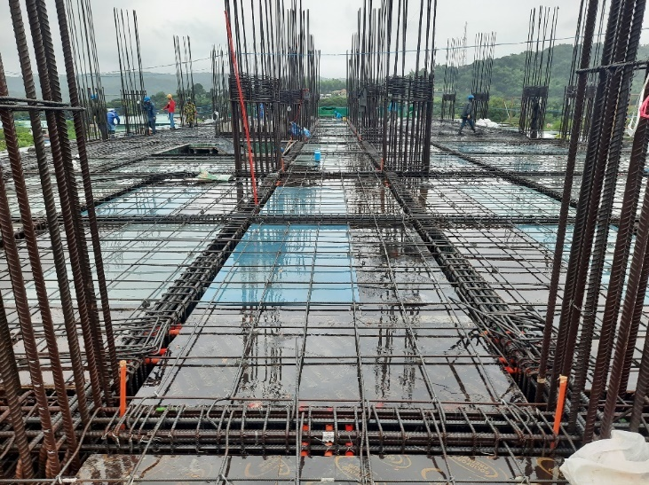  Laid slab bottom rebars  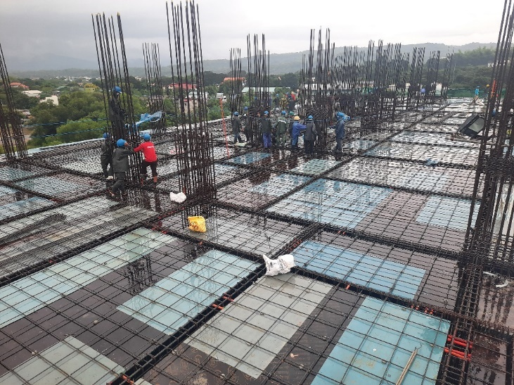  Laid slab bottom rebars  - Lay the top bar holder in a perpendicular direction to the top bars.  - Lay and tie the top bars spaced exactly as indicated on the approved cutting list. If there are provisions for extra top bars, its installation will come next after the continuous top bars are laid. Observe the proper concrete cover for the slab reinforcements.  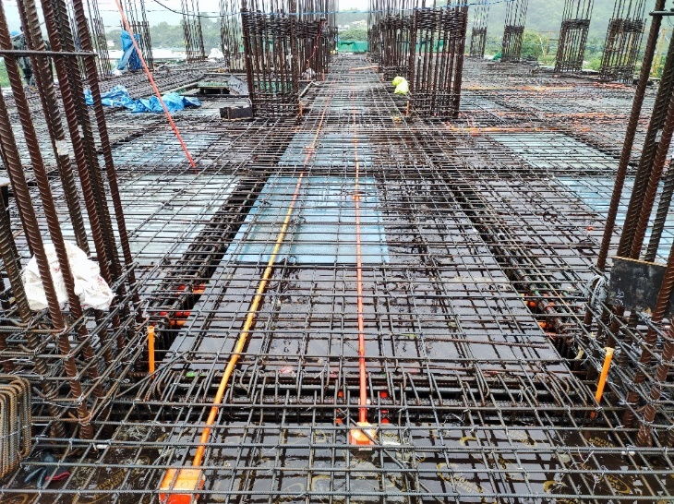  Installed slab bottom and top reinforcements  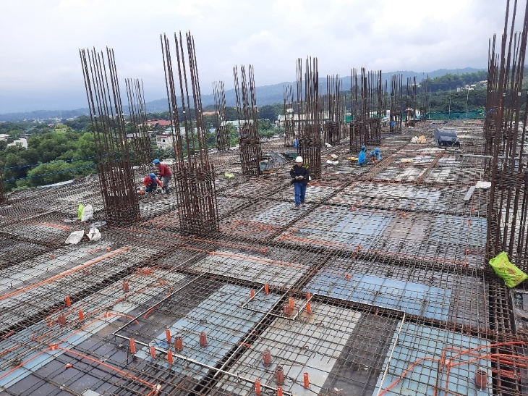  Installed slab bottom and top reinforcements  - Install the correct spacer/support between the top and bottom reinforcements. Concrete spacers should also be directly beneath the bottom reinforcements.  - Install the required trimmer bars at corner edges and openings. For chb partitions, it is advisable to install the dowel bars after pouring through drilling and application of concrete epoxy once the final lay-out of the partitions has been made. Refer to product specifications for the technical specifications and application methodology.  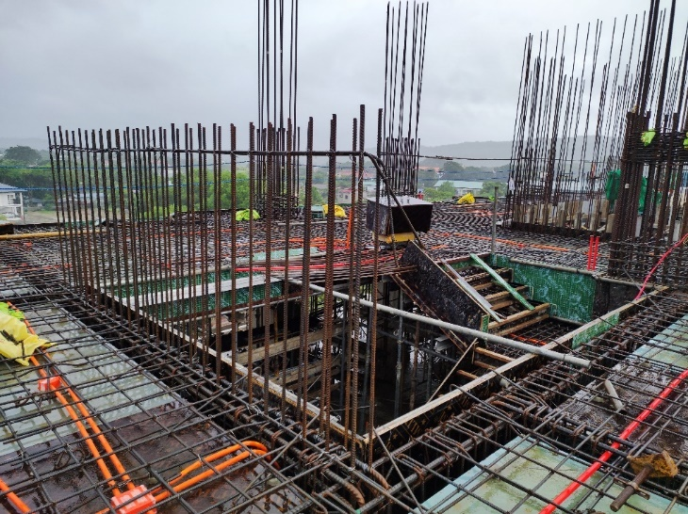  Installed reinforcement bars for stair shearwall  - Install block out forms for slab openings, and slab terminations. Block-out forms for comfort rooms and balconies are installed only if it is advised by the architect or the structural designer to provide depression. Refer to the structural designer for the dropping of slab and beams affected by the depression.  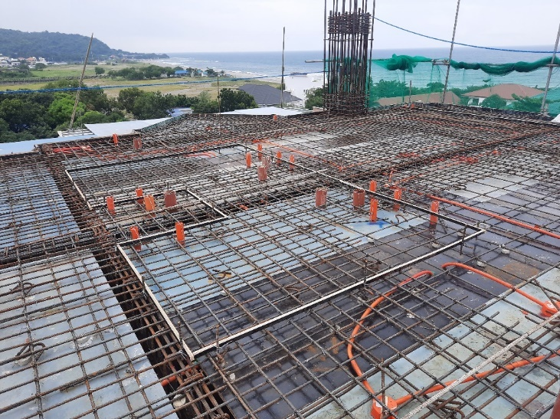  Installed block-out forms for comfort rooms  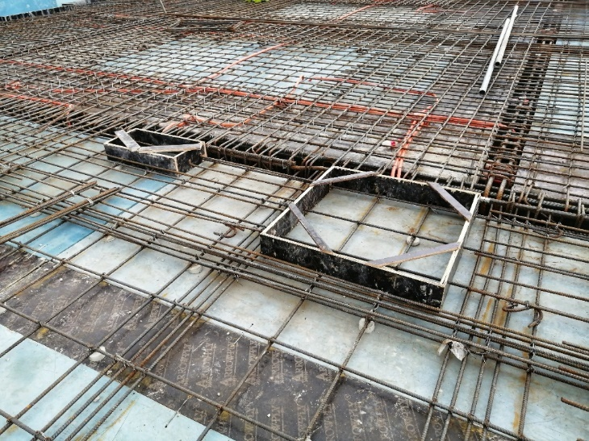  Installed block out forms for slab openings  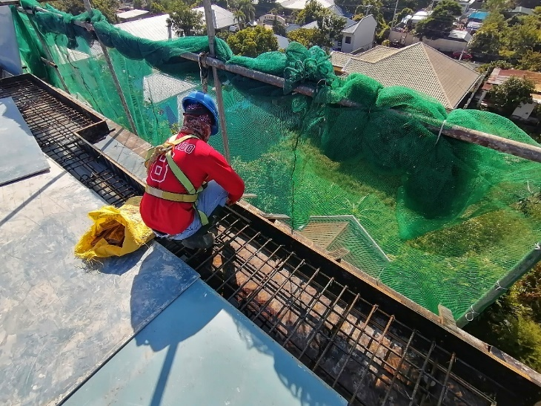  Installation of block out forms for slab terminations  - Establish pouring guides to maintain the thickness of slab when casting the concrete.  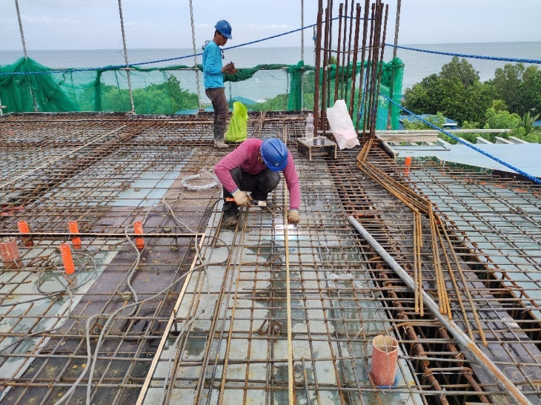  On going installation of concrete pouring guides for slab  - Throughout the implementation of the rebar and form works, the quality control engineer ensures the correctness of the implementation by inspection of the quantity, placement, alignment, and positioning of all the materials and scaffolds installed. Any discrepancies shall undergo adjustments prior to the concrete pouring of foundation.  5.3.4 Concrete works  - Prior to concrete pouring, a concrete trial mix shall be conducted to determine the proper concrete mixture that will satisfy the design strength of concrete to be used.  - Site inspection shall also be conducted by the quality control manager and/or quality control engineer before the concrete pouring to ensure that all works are taken out in accordance with the design specifications. Accomplish the pouring request form which will be the approval form of the concrete pouring.  - For vertical structures, concrete platforms are assembled which are on the same level as the top of the installed formworks. This platform will be the working area of the pouring manpower and serves as the concrete chute or mixing board.  - Concrete shall be placed dependent on access and pour configuration either by direct pouring or using a concrete pump.  In cases of direct pouring, concrete chutes or mixing boards are set-up where the concrete will travel or placed before its casting on the members. For concrete pouring using a concrete pump, concrete pipes and the pumpcrete are set-up by the facilities group hours or a day before the scheduled time of concrete pouring.  - All necessary tools for fresh concrete quality testing shall be readily available on site prior to the pouring of concrete. In the presence of a third-party representative, they should be available on site or at the batching plant to monitor if the concrete being supplied is in accordance to the specifications and its consistency is being met. Conduct slump cone test which measures the consistency of concrete. Acquire concrete samples that will be tested to determine the actual strength of casted concrete. Refer to the FCLDC QAQC manual on the standards of slump cone test and concrete cylinder testing.  - For pouring vertical members, the concrete are casted by layer at least one third the height of the forms and so on. Each layer shall be placed and compacted by vibrators before receiving the next layer. Layers should be placed before the initial set of the previous layer.  For pouring of horizontal members, the concrete is continuously dispatched at the area and spreaded manually by the concrete manpower.  - Full compaction of the concrete shall be achieved throughout the entire depth of the layer using a mechanical vibrator. Care shall be taken to avoid over vibration which can cause segregation, surface laitance or leakage through formwork.  - Construction joints are provided as required during construction in accordance with the standards and technical specifications. It will be prepared to achieve good bonding between old and new concrete.  5.3.5 Concrete curing  - All freshly placed concrete surfaces will be protected from damages and from harmful effects of weather including rain, sun, and wind. Freshly poured concrete surfaces shall be covered or protected by a plastic sheets or burlap. Refer to FCLDC QAQC manual for additional methods of concrete curing.  - In order to obtain good quality concrete, curing shall be done by watering the newly poured concrete after it has set using potable water or other prescribed curing agents.  - Concrete curing will be done up to period as per required to achieve the design strength. Curing shall commence immediately after finishing and normally continued for 7 days and shall be done as per standards.  5.3.6 Dismantling of forms  1. After the concrete has cured and attained sufficient strength, the formwork can be removed. Be mindful to follow the recommended curing time before removing the formwork to avoid any damage to the newly poured concrete. The recommended days of form removal are indicated in the construction specifications. Also consider the test results of the concrete samples in the gradual removal of forms. Remove the formwork progressively and systematically to prevent any sudden shifts or disturbances. | Approved plans,  Requests for Information,  Requests for Approval  Approved plans,  Plans and Specification,  NSCP 2015,  Formworks checklist,  Rebarworks checklist  Rebar Cutting list  Assembled scaffolds for column reinforcement supports  Installed column reinforcements  Provision of key for Construction joint  Shear bars for construction joint  Approved Construction plans  Top bars  Chair bars  Bottom bars  Concrete pouring guide  Approved plans,  Plans and specifications,  NSCP 2015,  Rebarworks checklist,  Formworks checklist  Installed water stop  Approved plans,  Plans and specifications,  NSCP 2015,  Rebarworks checklist,  Formworks checklist  Approved plans, Pouring Request Form, FCLDC QAQC manual  FCLDC QAQC manual  Plans and specifications,  FCLDC QAQC manual
 | 5.4 Work Inspection
Site Engineer,  Quality Control Engineer | The engineers must always monitor the progress of work and ensure that instructions are being sustained.  Ensure that the work is accomplished in accordance to the quality requirements. Check if there are defects and rectify any issues that are identified. Use the formworks checklist (FM-OPN-02-13), rebarworks checklist (FM-OPN-02-12), concrete works checklists (FM-OPN-02-11), and the FCLDC QAQC to guide you on what items to check during your inspection. | Approved plans,  Formworks Checklist,  Rebarworks Checklist,  Concreteworks Checklist,  Pouring request form,  FCLDC QAQC manual

7.0 APPENDICES

FM-OPN-02-04 Requests for Approval

FM-OPN-02-05 Requests for Information

FM-OPN-02-11 Concrete works checklist

FM-OPN-02-12 Rebar works checklist

FM-OPN-02-13 Formworks Checklist

FM-OPN-02-01 Pouring Request Form

